Paradigm Energy Partners Services Overview
With over 30 years experience at Energy Transition Leader NextEra Energy, PEP experts help our clients tackle their most demanding challenges, from growth strategies and M&A support to operations reengineering and expert witness services.
PEP’s Unique Qualifications
- Decades of technical & commercial operating experience at NextEra Energy
- Broad & deep expertise across solar, wind, storage, H2, EV, DER and grid
- Vast network of trusted contacts across the Energy Transition industry
- Decision makers with accountability for $ Billions, technical safety, and lives

Challenge: Growth strategy, Investment and M&A

Growth Strategy, Market & Target Assessment Services
PEP will develop growth strategies customized to the client’s objectives, capabilities and fit with their current business. Analyzing target markets for size, growth, profitability, competition, complexity and ease of entry, PEP will identify and prioritize potential targets for investment or M&A, providing the client with an executable plan to grow their business.

Target Identification & Assessment
Given client’s decided-upon growth plan and target markets, PEP will identify a list of potential M&A targets meeting the client’s stated objectives. PEP will assess these targets technically and commercially, as well as using its network of industry contacts, providing the client with an in-depth understanding of the potential and risks of transactions under consideration.

Due Diligence Services
Once a client enters the Due Diligence phase of an M&A or investment opportunity, PEP will cover the technical, business and practical IP aspects of the review, as well as offer insights from its peer network into the industry reputation of the target, its officers and key personnel. Equipped with a 360-degree view, the client can execute its plan with confidence.

Post M&A integration Planning & Execution
As the client consumes M&A transactions, PEP will develop a practical plan for post-merger integration tailored to the client’s and the target’s current organization and capabilities. Applying their experience with many M&A transactions and organizational integrations across many areas of the electric industry, PEP experts provide expert guidance during implementation, lowering friction and costs while ensuring success.

Challenge: Develop and grow Industry & Customer Relationships

Ecosystem Strategy Development & Implementation
Many clients consider entering the Energy Transition industry, broadening their footprint into new sub-industries unfamiliar to them, or expanding from overseas to the North American market. PEP will assess the industry environment, identify high value partner or customer relationships tailored to the client and make executive introductions. Deeply familiar with the parties’ businesses and objectives, PEP will develop “win-win” approaches for the involved parties and support their realization.

Energy Industry Advisory Services
For clients seeking deeper insights into the workings of the energy transition industry, PEP experts offer their inside knowledge, technical and business understanding as well as access to industry decision makers via PEP’s network of contacts As PEP experts have spent their entire careers structuring, reviewing, approving and executing projects across the industry, their insights can drastically enhance the client’s rate of success.

Relationship Management with High Impact Energy Transition Players
PEP experts function as an extension of the client’s senior team, representing the client in all matters regarding a targeted or current relationship. Bringing to bear the trust earned through decades of service in the industry, PEP experts will design tailor-made strategies to get favorable reviews and decisions for the client, while identifying and promoting “win-win” approaches that measurably contribute to the business success of both client and target.

Challenge: Client’s Technical, Operational or Organizational Business Improvement and Support

Technical Expert Services
PEP experts are widely recognized for their deep technical expertise across all aspects of the Energy Transition. Clients may engage PEP to
- lead, plan or support system/equipment design, performance, reliability and availability
- Assess new electrical generation, storage, transmission and distribution technologies, approaches or methods
- Implement statistical quality control tools and lean engineering approaches

Operational Improvement Services
As decision makers and accountability owners for the operations of energy equipment across several decades, PEP experts can help clients assess and improve the operations of their businesses across the board. Clients engage PEP to
- Evaluate and report on the state of operations for a facility or business
- Develop customized plans to improve operational effectiveness to achieve agreed upon business-based success outcomes
- Provide qualified and experienced experts to lead the execution of agreed upon performance improvement plans

Organizational Improvement Services
PEP experts have designed and iterated on organizational structures for high performance throughout their careers in the Energy Transition. Clients rely on PEP’s expertise to
- Assess and report on strengths/gaps of client’s organizational structure, staffing practices and skills
- Develop customized proposals, including training and change management plans, to improve organizational effectiveness to achieve agreed upon business-based success outcomes
- Function as qualified and experienced experts to lead the execution of organizational improvement plans

Expert Witness Services
With decades of experience dealing with regulatory and legal issues in the Energy Transition, paired with deep technical expertise in its challenges, PEP experts are well positioned to support clients and their legal representatives in related questions such as major equipment warranty claims, system non-performance problems, and others. PEP will
- Represent client as expert witness for legal or regulatory proceedings
- Provide expert analysis of client’s legal documents in all technical and regulatory regards

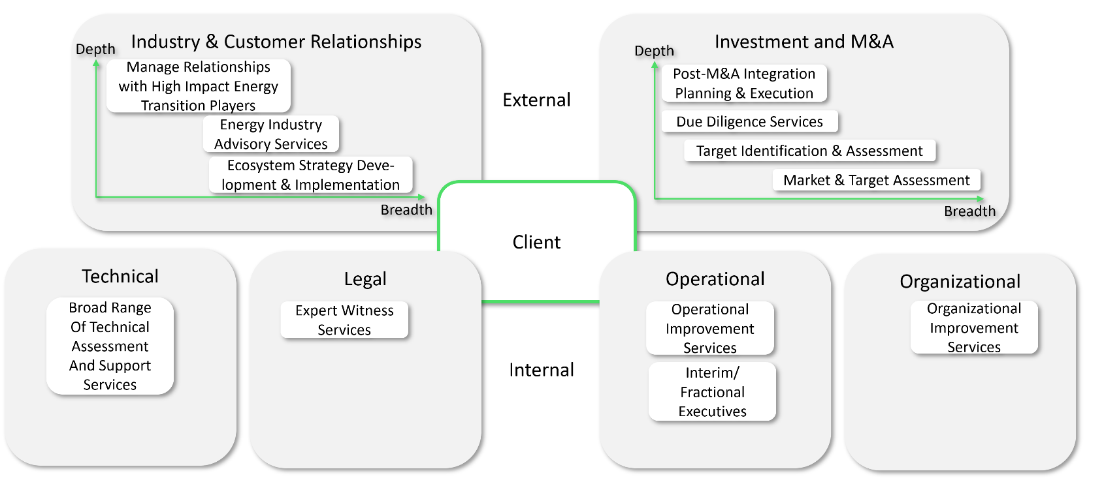
Overview of PEP’s Services To Energy Transition Clients

What PEP can do for you
If you are considering M&A or investing significant resources into the Energy Transition, PEP is here to help you. Our industry experts have decades of unique industry experience that allows us to identify the most promising opportunities, conduct due diligence grounded in realism, and avoid pitfalls, making sure you achieve your objectives while limiting risk. Contact us at info@paradigmenergy.partners for an initial consultation.

